Jennifer DeVore

23 March 2020

CIS 435

**Unit 4 Graded Exercise 2: Working with Functions and Triggers**

**5. Create a scalar-valued function named fnUnpaidInvoiceID that returns the InvoiceID of the earliest invoice with an unpaid balance. Test the function in the following SELECT statement: SELECT VendorName, InvoiceNumber, InvoiceDueDate, InvoiceTotal - CreditTotal - PaymentTotal AS Balance FROM Vendors JOIN Invoices ON Vendors.VendorID = Invoices.VendorID WHERE InvoiceID = dbo.fnUnpaidInvoiceID();**

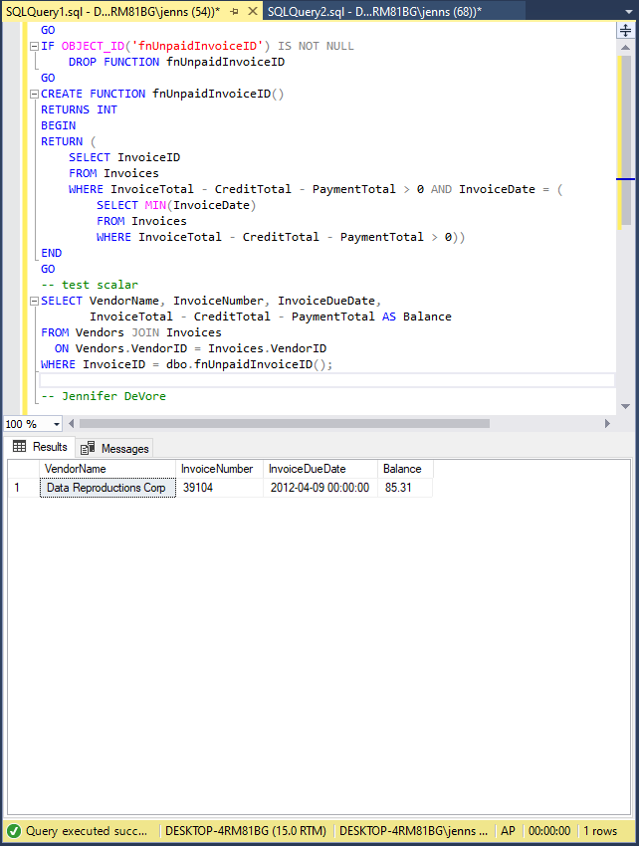

**8. Create a trigger for the Invoices table that automatically inserts the vendor name and address for a paid invoice into a table named ShippingLabels. The trigger should fire any time the PaymentTotal column of the Invoices table is updated. The structure of the ShippingLabels table is as follows: CREATE TABLE ShippingLabels (VendorName VendorAddress1 VendorAddress2 VendorCity VendorState VendorZipCode varchar(50), varchar(50), varchar(50), varchar(50), char(2), varchar(20)); Use this UPDATE statement to test the trigger: UPDATE Invoices SET PaymentTotal = 67.92, PaymentDate = '2012-04-23' WHERE InvoiceID = 100;**

